**Audit Package Documentation**

1. This is the file structure for the package that we are trying to build.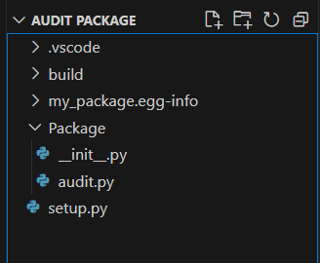
2. Leaving everything aside, lets focus on audit.py as its the main .py file

1. first import all the required packages

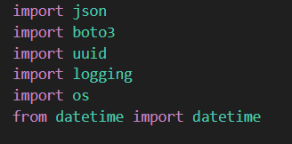

2.lets configure the logger module to use it for logging purpose

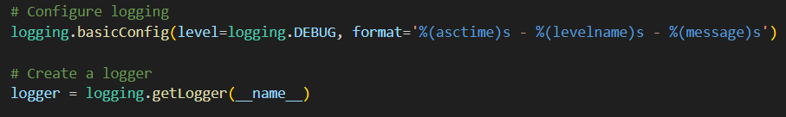

3.pass the bucket name as an environment variable and call it into a variable in your code

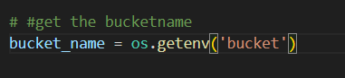

4.call the “audit” function and get the data into a JSON structure

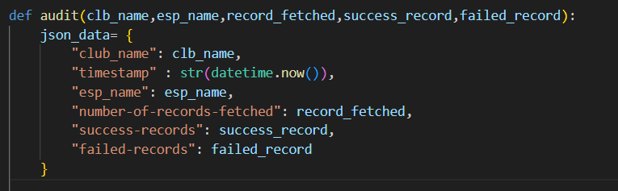

5. now let's come to the “try:” method. Here we are creating a unique id for every JSON that it will create. We are using python in build library to get the current time and date. We are even configuring the format for it so that the folder structure inside S3 is prepared accordingly.

6.we are using boto3 to connect to S3_client and push our JSON data to the bucket mentioned in the variable.

7. we are using the “Logger()” to log the success and returning “TRUE” if success

8. Even using “Raise” to raise an exception if any .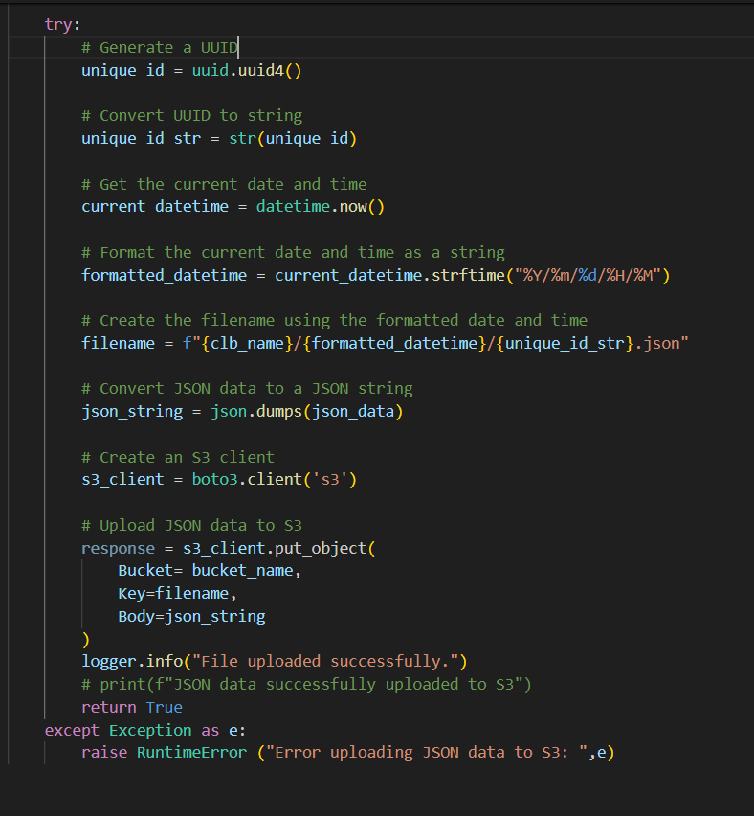

1. for testing the above package, we can simply call the package and use it according to logic.

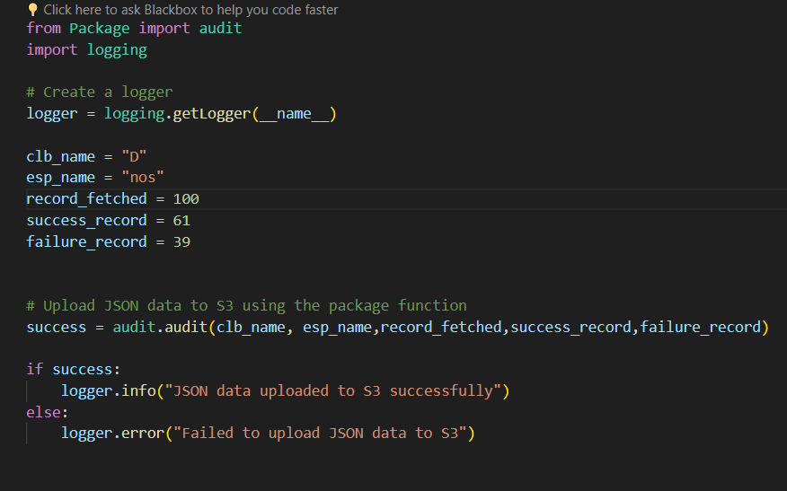

1. after running the test script you can go and check the S3 bucket. The folder structure will look something like the image below.



You can find the JSON file with a unique file name like the image below.

